**DEM ASSIGNMENT PART-1**

**Code:**

clearall

clc

symsLdsMdLdrLqrRdsRr W s P J E

P=50*746 % Power in watts

V=460 % line to line voltage (rms)

% f=60 % frequency in Hz

g=1

forf=1:1:60

W=2*pi*f

Rds=0.087

Xls=0.302

Lls=Xls/2*pi*60

Xm=13.08

Md=Xm/2*pi*60

Rr=0.302

Xlr=0.228

Ldr=Xlr/2*pi*60

Lqr=Xlr/2*pi*60

Lds=Xls/2*pi*60

J=1.662

B=inv([Lds,Md,0;Md,Ldr,0;0,0,Lqr])

A=-B*[Rds,0,0;0,Rr,Lqr*W;-W*Md,-W*Ldr,Rr]

E=eig(A)

[V,D]=eig(A)

k(g)=E(1)

l(g)=E(2)

m(g)=E(3)

h(g)=f

g=g+1;

end

plot(h,k)

holdon;

plot(h,k,'k*')

holdon;

plot(h,l)

holdon;

plot(h,l,'r*')

holdon;

plot(h,m)

holdon;

plot(h,m,'b*')

holdon;

**Results:**

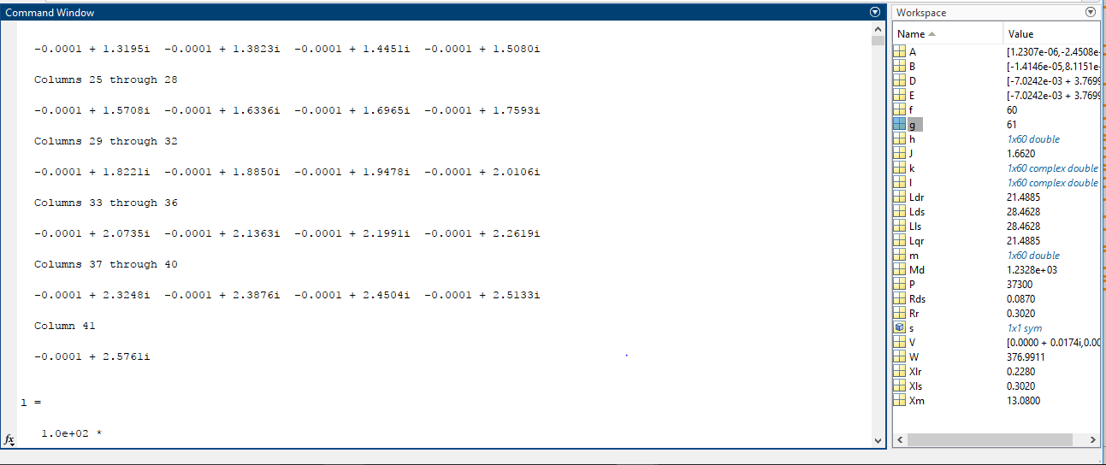

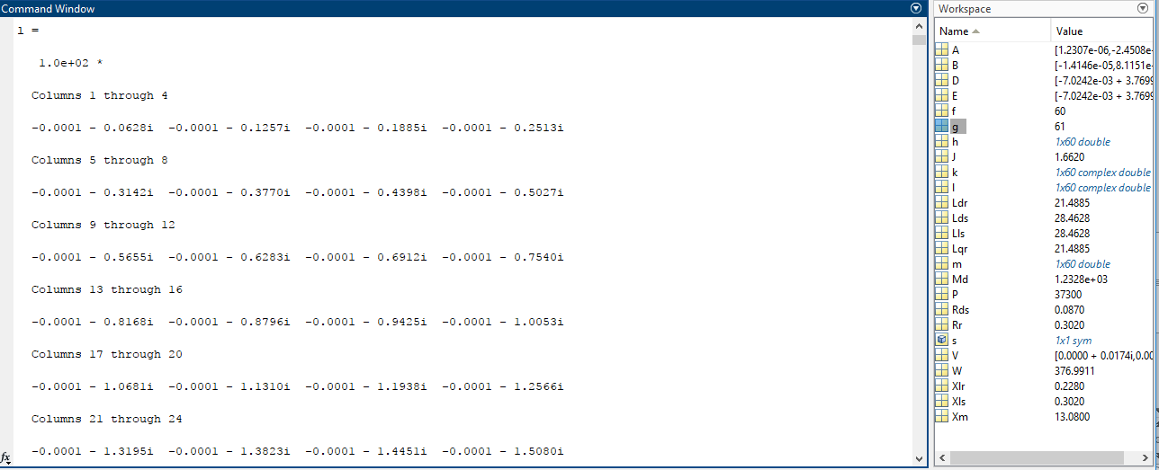

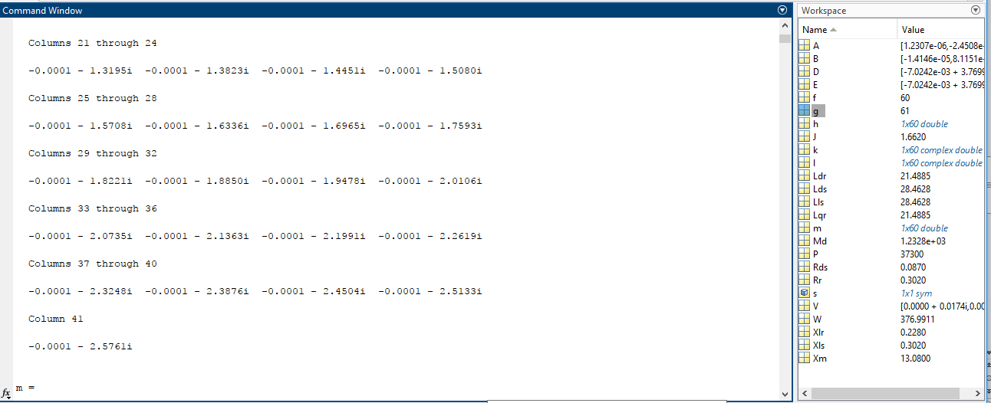

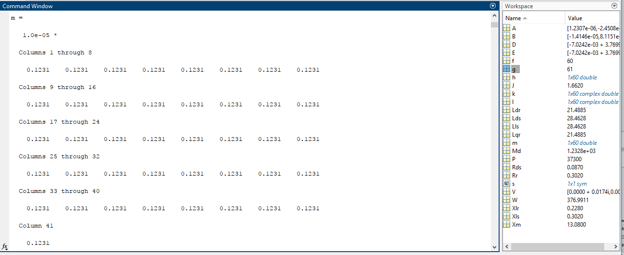

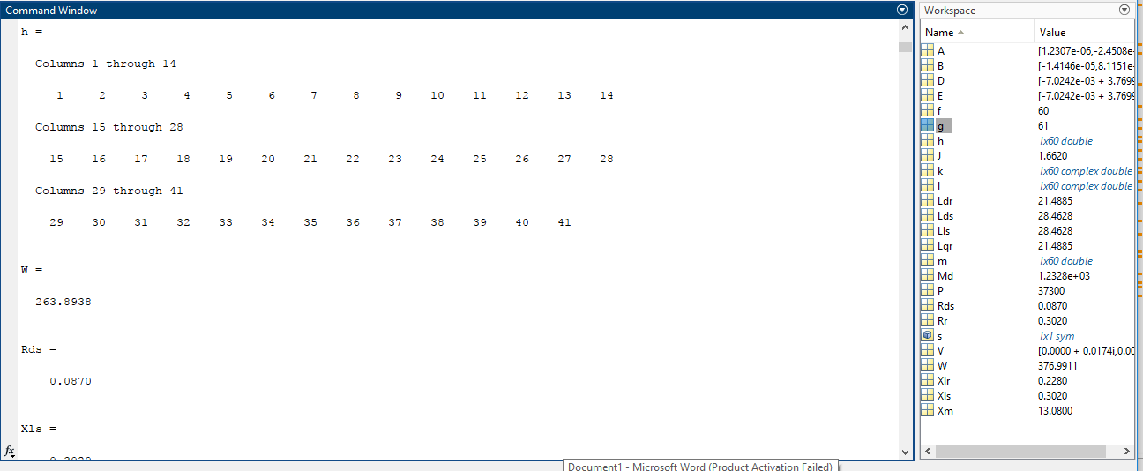

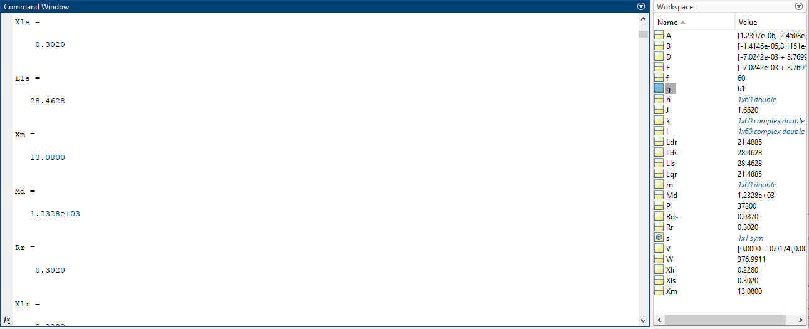

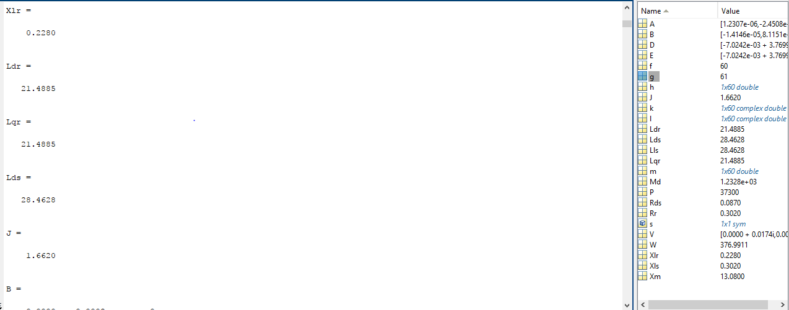

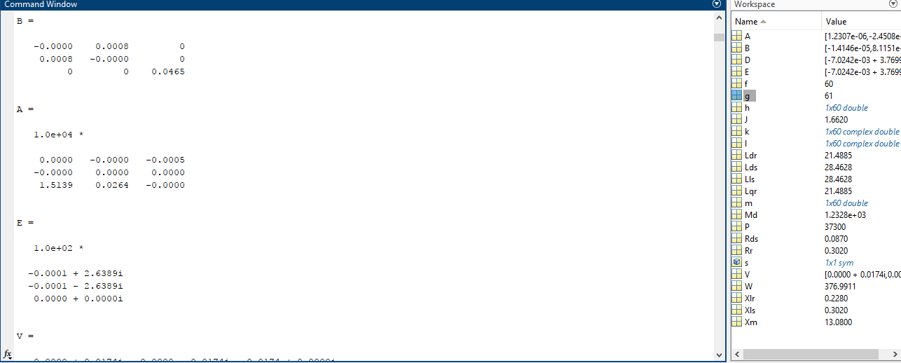

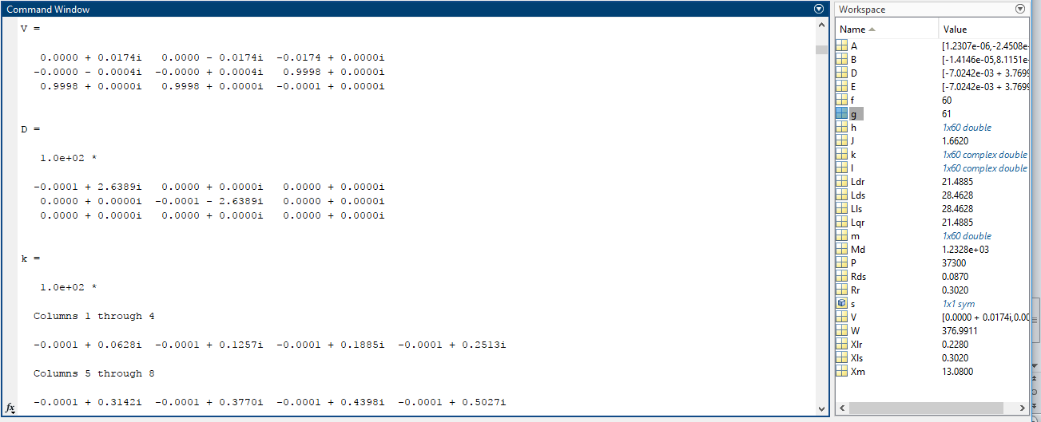

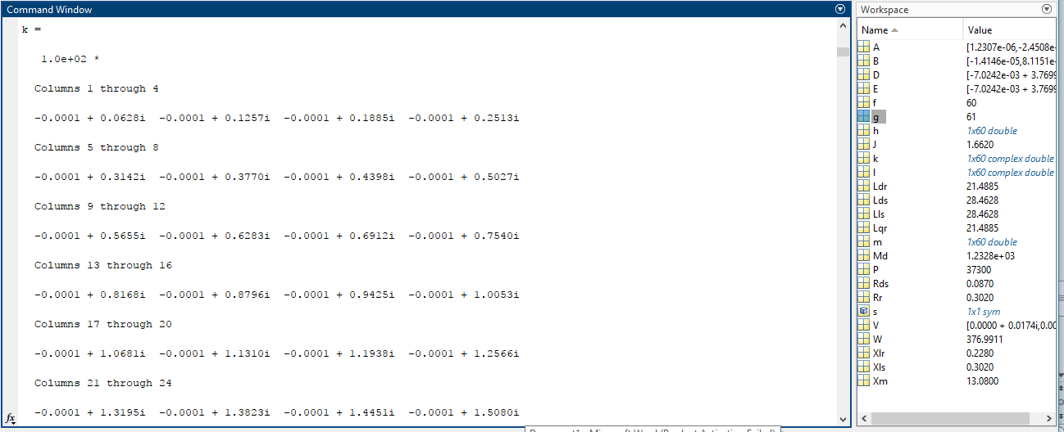

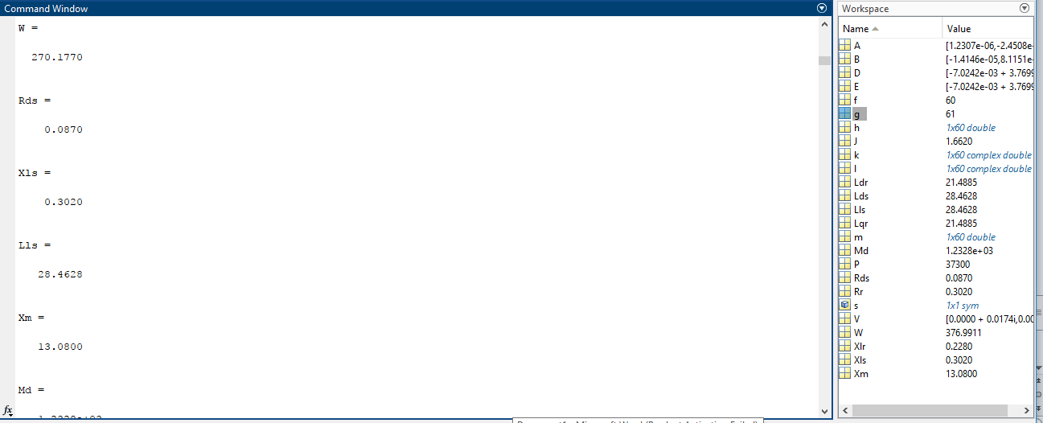

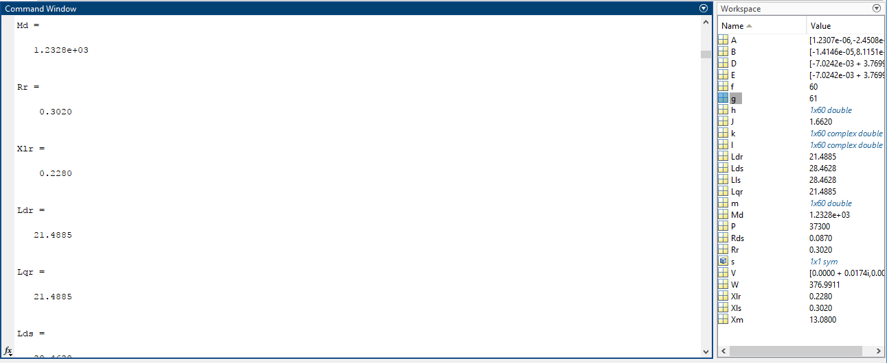

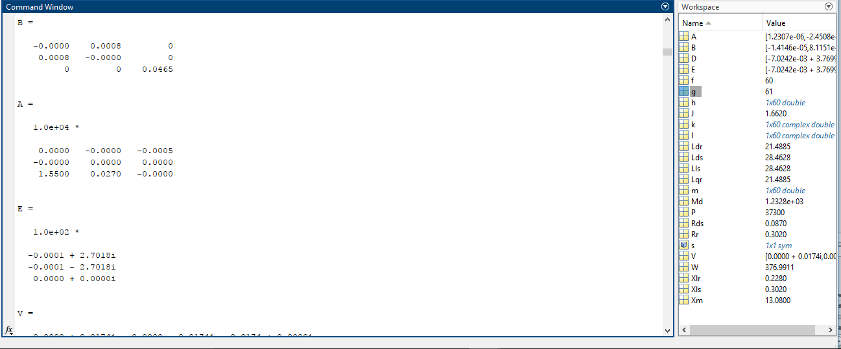

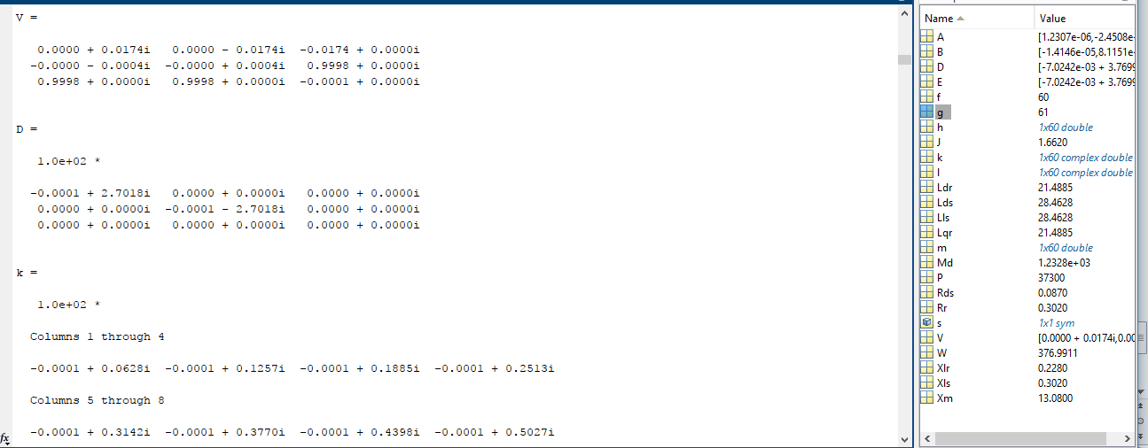

Like that it will execute the loopfor different frequency

**Plot:**

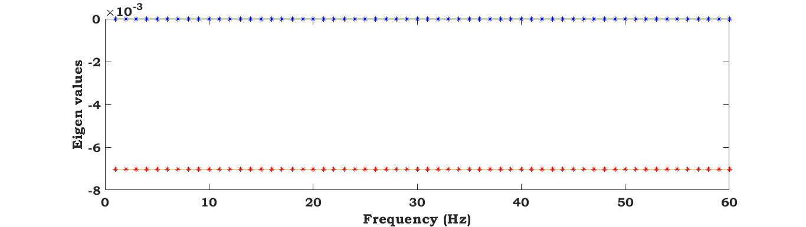

Name :

Roll number :